Matt Gottstine

English 9

April 17, 2012

Image Share

Act IV Scene I

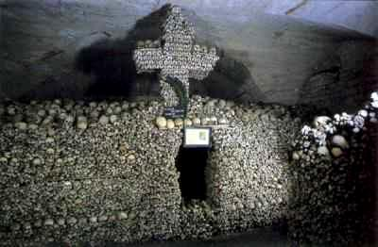

In this scene Friar Laurence helps Juliet to plan her escape from Verona. The plan is for Juliet to go home, request to be alone, and then drink from a vial that will make her appear dead. After her burial in the Capulet family charnel house, Friar Laurence accompanied by Romeo who he had sent for, Juliet will awake and be taken to Mantua with Romeo. This is significant because it shows the determination of love by Juliet, who will fake her own death to be with Romeo. Also she is willing to be placed next to her recently dead cousin, Tybalt, who was slain by Romeo, in order to be with Romeo.